**ANYA ( MOBILE APPLICATION FOR EARLY SCREENING AND INTERVENTION FOR POSTPARTUM DEPRESSION )**

### **A PRODUCT DEVELOPMENT REPORT**

***Submitted to***

### **SAVEETHA INSTITUTE OF MEDICAL AND TECHNICAL SCIENCES**

***In partial fulfillment of the award of the degree of***

### **BACHELOR OF ENGINEERING**

***By***

### **Name and Reg Number : KRISHVANTH KUMAR E (192125063)**



**SIMATS ENGINEERING**

**SAVEETHA INSTITUTE OF MEDICAL AND TECHNICAL SCIENCES,**

**CHENNAI – 602 105**



# **SIMATS ENGINEERING**

**SAVEETHA INSTITUTE OF MEDICAL ANDTECHNICAL SCIENCES**

### **CHENNAI – 602105 BONAFIDE CERTIFICATE**

Certified that this product development report **“ANYA (** MOBILE APPLICATION FOR EARLY SCREENING AND INTERVENTION FOR POSTPARTUM DEPRESSION **)”** is the

Bonafide work of **“KRISHVANTH KUMAR E”** who carried out the product development work under my supervision.

 

# **HEAD OF THE DEPARTMENT**

Professor

Department of Computer Science and Engineering

SIMATS Engineering

Saveetha Institute of Medical and Technical Sciences

Chennai – 602105

# **SUPERVISOR**

Professor

Department of Computer Science and Engineering

SIMATS Engineering

Saveetha Institute of Medical and Technical Sciences

Chennai - 602105

## **INTERNAL EXAMINER EXTERNAL EXAMINER**

**INDEX**

| **S.NO** | **TOPICS** | **PAGE NO** |
| --- | --- | --- |
| **1** | INTRODUCTION | **1** |
| **2** | DESIGN PROCESS | **2** |
| **3** | SYSTEM ARCHITECTURE | **4** |
| **4** | DESIGN DETAILS | **6** |
| **5** | TECHNICAL SPECIFICATIONS | **7** |
| **6** | PROTOTYPING PHASE | **7** |
| **7** | IMPLEMENTATION PLAN | **9** |
| **8** | TESTING AND VALIDATION | **11** |
| **9** | DEPLOYMENT AND MAINTENANCE | **12** |
| **10** | SAMPLE IMAGES OF THE AUTOMATIC RANGOLI DRAWING DEVICE IN OPERATION | **13** |
| **11** | CONCLUSION | **15** |
| **12** | PATENT PUBLISHED PROOF | **16** |

**MOBILE APPLICATION FOR EARLY SCREENING AND INTERVENTION FOR POSTPARTUM DEPRESSION**

**APPLICATION NAME: “ANYA”**

**1. Introduction :**

In recent years, there has been increasing recognition of postpartum depression (PPD) as a significant mental health challenge that affects many women during the perinatal period. "ANYA" is an innovative mobile application designed to facilitate early screening and intervention for PPD, providing a vital resource for new mothers. This app aims to bridge the gap in mental health care by leveraging technology to enhance accessibility, improve early detection, and offer personalized support for women experiencing PPD. The app acknowledges the barriers that postpartum women face in seeking help, including stigma and limited access to mental health services. "ANYA" offers a user-friendly platform for women to monitor their mental health and receive timely interventions, ultimately promoting better outcomes for both mothers and their children.

**Objective:**

The primary objective of "ANYA" is to provide postpartum women with an accessible and effective tool for screening PPD symptoms and facilitating early interventions. The app aims to empower users to track their mental health, access educational resources, and receive personalized support tailored to their needs.

**Scope :**

"ANYA" is designed for mobile platforms and targets pregnant women and new mothers. Key features include mood and sleep tracking, standardized self-evaluation questionnaires, personalized intervention schedules, immediate alert notifications, and access to educational materials on PPD.

**Background:**

The motivation behind developing "ANYA" stems from the urgent need for effective screening and intervention methods for postpartum depression. Traditional approaches often fall short due to accessibility issues and the stigma associated with mental health. This app seeks to utilize advancements in digital health to improve the detection and management of PPD, ensuring women receive the support they need.

**Requirements:**

To develop "ANYA," the following tools and technologies are utilized:

**Programming Languages:**

Flutter, PHP, Dart, JAVA

**Development Tools:**

Android Studio (for Android), Visual Studio Code (for IOS)

**Database:**

XAMPP and MySQL

**User Interface Design:**

Figma (for creating wireframes and app design)

**Project Overview :**

**Scenario:**

"ANYA" addresses the critical need for effective postpartum depression screening and intervention, aiming to enhance mental health outcomes for new mothers.

**Purpose:**

The app simplifies the screening process and provides immediate access to resources and support, reducing barriers to care.

**Main Features:**

Key features include mood and sleep tracking, interactive chatbot support, self-evaluation questionnaires, stress management schedules, and educational content.

**Outcomes:**

"ANYA" is expected to empower postpartum women by providing them with the tools and support necessary to manage their mental health effectively. The app aims to foster a supportive environment that encourages open communication about mental health concerns, ultimately leading to improved maternal and child health outcomes.

**2. Stakeholders :**

Roles in the Project Development

**Project Manager and Developer (Sole Contributor):**

Responsible for all aspects of design, development, and deployment of "ANYA."

**Users:**

Pregnant women and new mothers utilizing the app for screening, support, and resources.

**3. Project Plan :**

Roadmap for the Project

The project follows a phased development approach to ensure timely delivery and efficient execution:

**Phase 1:** Planning and Design

**Phase 2:** Database Setup

**Phase 3:** iOS App Development

**Phase 4:** Android App Development

**Phase 5:** Testing and Quality Assurance

**Phase 6:** Deployment and Launch

| **Task** | **Start Date** | **End Date** | **Duration** |
| --- | --- | --- | --- |
| **Project Initiation, Research** |  |  |  |
| **Database Development** |  |  |  |
| **Android development** |  |  |  |
| **IOS Development** |  |  |  |
| **Testing** |  |  |  |
| **Deployment and Launch** | - | - |  |

**Progress Overview :**

**Planning and Design Phase:**

Completed, focused on wireframes and user experience design.

**Database Setup:**

Completed, involving Firebase for data storage.

**App Development Phases :**

In progress, with iOS development completed and Android development underway.

**Testing Phase:**

Scheduled to begin after app development.

**Deployment:**

Expected to be completed within the next two months.

**4. Functional and Non-Functional Components:**

**User Roles and Responsibilities :**

**Postpartum Women:**

Primary users responsible for tracking mental health, completing self-evaluation, and following intervention recommendations.

**Version History :**

**Version 1.0 :**

Initial release focused on screening, mood tracking, and personalized interventions for postpartum depression.

Summary of the Invention The invention consists of a mobile application that offers the following resources and features:

**Tracker Tools:**

Users can monitor daily activities that influence mood and behavior.

**Self-Evaluation Questionnaires:**

Regular assessments to evaluate mood and symptoms.

**Stress Management Schedule:**

Activities for stress relief tailored to user needs.

**Immediate Alerts:**

Notifications sent to users and healthcare providers if symptoms escalate.

**Educational Materials:**

Resources on PPD and coping strategies.

**Chatbot Feature:**

Access to expert insights and support for common concerns.

Claims of the Invention I/We Claim:

**1. Mood and Sleep Tracking Features:**

Built-in functionalities for tracking mood and sleep patterns.

**2. Interactive Chatbot Support:**

A chatbot feature for personalized support and guidance.

**3.Multi-User Accessibility:**

Supports profiles for mothers, healthcare providers, and guardians.

**4. Standardized Questionnaires Integration:**

Regularly administered questionnaires for monitoring mental health.

**5. Early Detection with Immediate Alerts:**

Alerts sent if symptoms exceed predefined thresholds.

**6. Seamless Treatment Integration:**

Immediate notification of concerning changes in mental health status.

**7. Curated Library of Resources:**

Access to meditation, mindfulness, and coping strategies.

**8. Comprehensive Data Access for Healthcare Providers:**

Seamless access to all user-entered data for ongoing treatment.

**9. Notification Alerts for User Engagement:**

Alerts to remind users for daily check-ins and assessments. Through these features and claims, "ANYA" represents a comprehensive approach to addressing postpartum depression, improving maternal mental health, and enhancing overall well-being for families.

**THE IMAGES OF UI :**

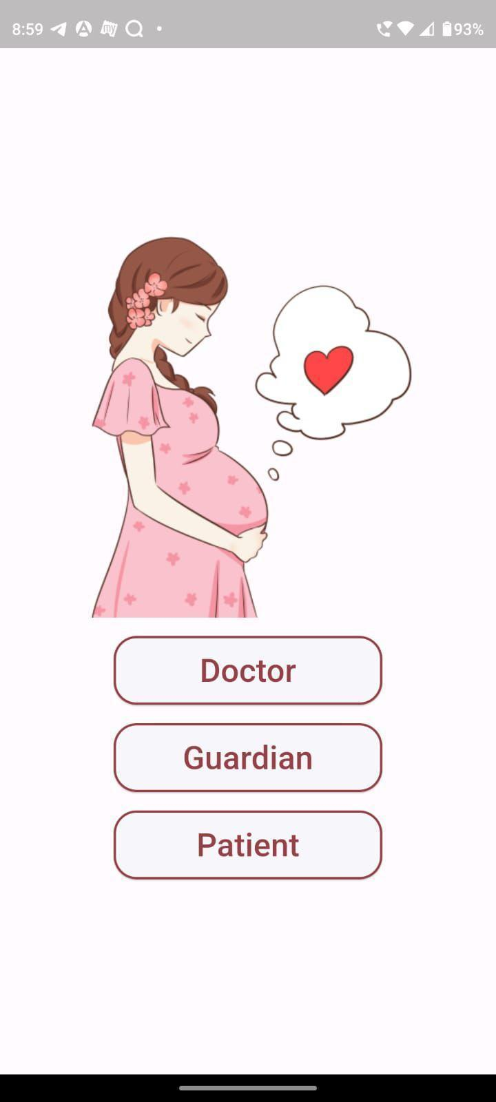

This image shows the login portal for multiple users.

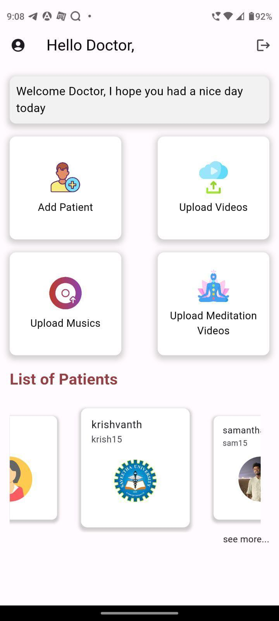

This is the consultant portal where he/she has access to patients portal, upload videos ,audios and also add new patients.

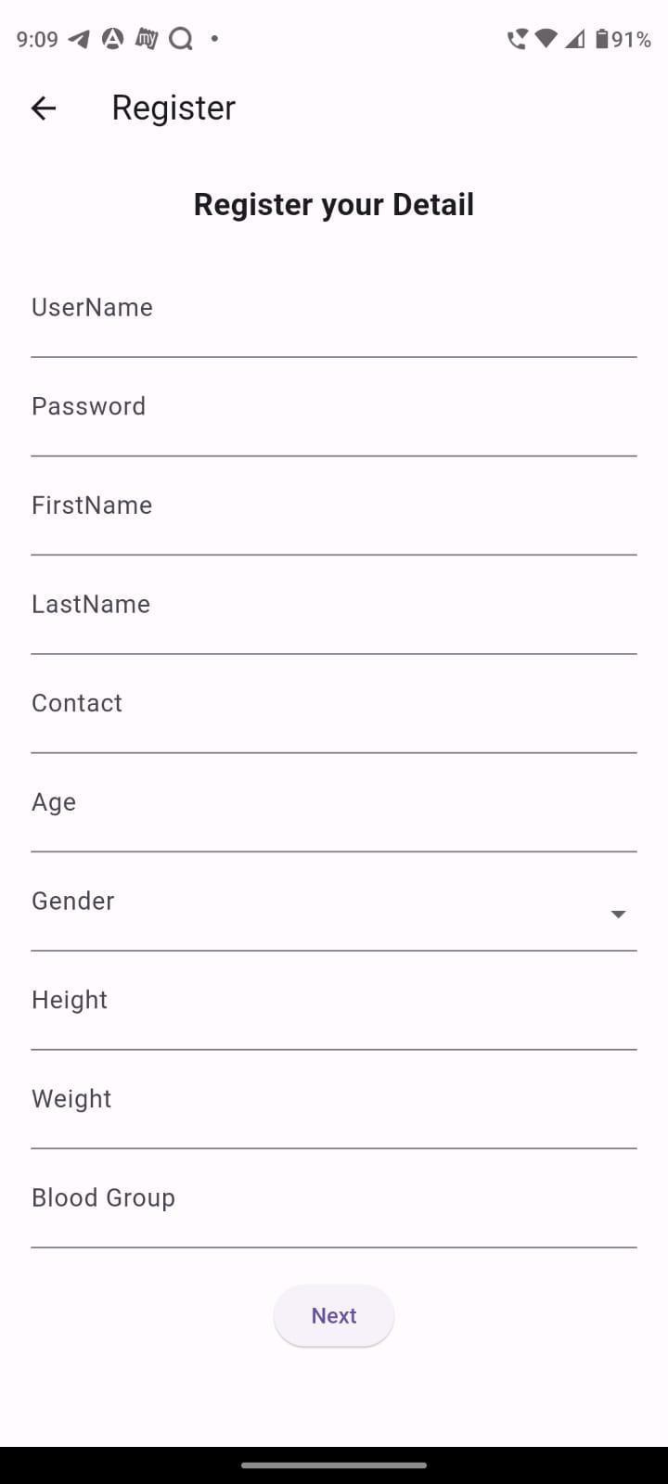

This image shows the place where the consultant can enter details of the patients at the outset end, with the data being seamlessly displayed in the patient profile for ongoing reference and treatment planning

The first image shows the main sign in portal for the patient.

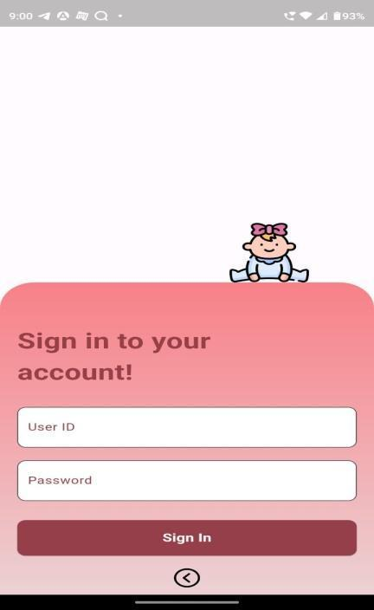

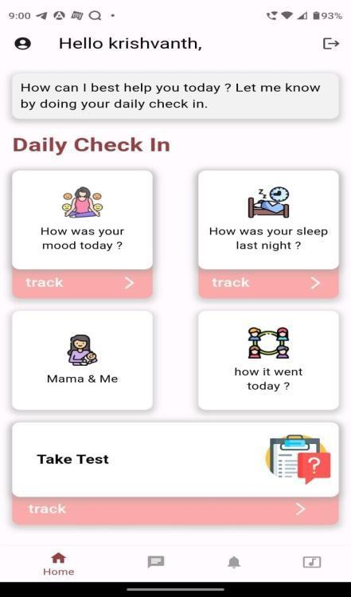

This image shows – the daily check- in, where patient enters their daily log.

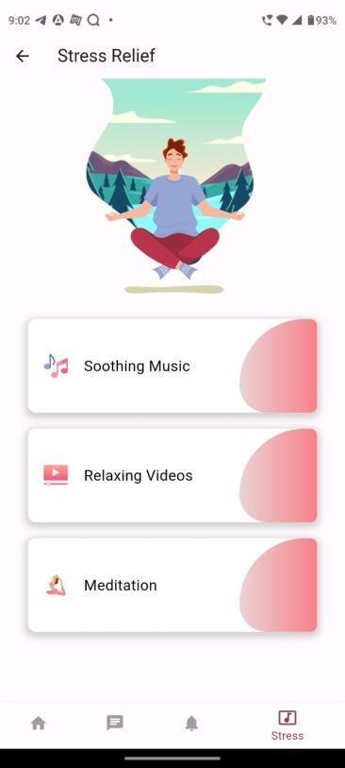

This image shows the various educational materials on post natal depression, coping stratergies and self care practices available for users.

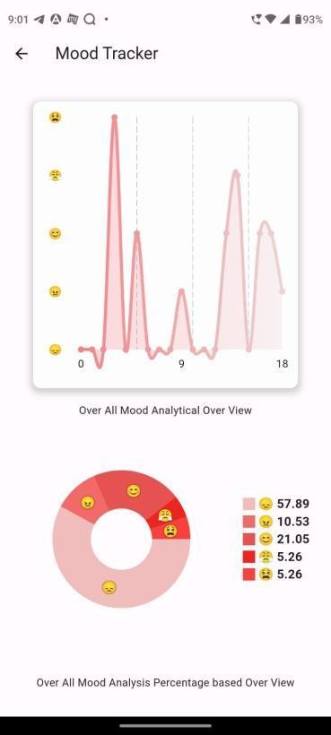

This image shows built-in mood tracking features based on the daily mood inputs.

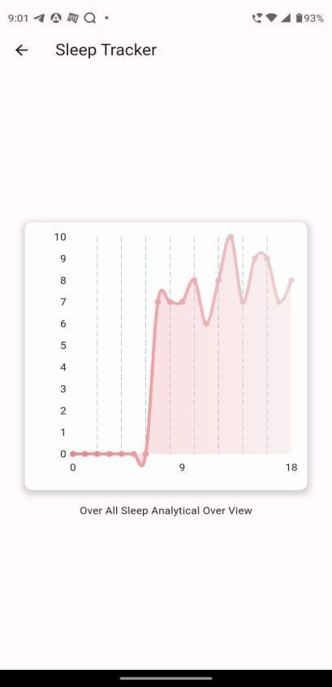

This image shows built-in sleep tracking features allowing users to record their sleep duration, quality providing insight to sleep patterns **.**

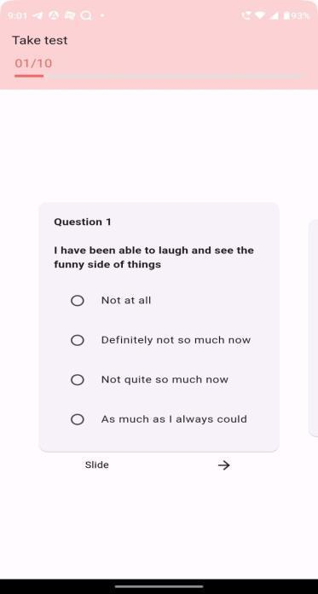

This image shows standardized self-evaluation questionnaires within the mobile application to assess symptoms of PPD.

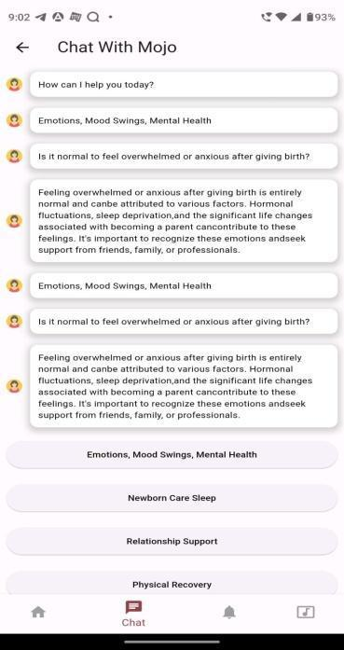

This image shows the interactive chatbot feature that engages the users in conversation to provide support guidance and information